

High Level Design & Low Level Design

**Document Control :**

|  |  |  |  |  |  |  |  |  |
| --- | --- | --- | --- | --- | --- | --- | --- | --- |
| **Project Revision History** | | | | | | | | |
|  |  |  | |  |  |  |  |  |
| **Date** | **Version** | **Author** | **Brief Description of Changes** | | | | **Approver Signature** | |
| 19.10.2022 | 1.0 | Group 6 |  | | | |  | |
|  |  |  |  | | | |  | |
|  |  |  |  | | | |  | |

**Index**

1. Introduction ------------------------------------------------ 4

1.1 Intended audience ------------------------------------------------ 4

1.2 Project purpose ------------------------------------------------ 4

1.3 Key project objective ------------------------------------------------ 4

1.4 Project scope and limitation ------------------------------------------------ 4

1.5 Functional overview ------------------------------------------------ 4

1.5.1 Header files ------------------------------------------------ 4

1.5.2 Functions ------------------------------------------------ 5

2. Design overview ------------------------------------------------ 6

2.1 Design objective ------------------------------------------------ 7

2.2 Design alternative ------------------------------------------------ 7

2.3 User interface paradigms ------------------------------------------------ 7

2.4 Error detection/ Exceptional Handling ------------------------------------------------ 8

2.5 Performance ------------------------------------------------ 8

2.6 Maintenance ------------------------------------------------ 8

3. System architecture ------------------------------------------------ 8

3.1 Structure ------------------------------------------------ 8

4. Detailed system design -----------------------------------------------10

5. Environment description ------------------------------------------------16

5.1 Time zone support ------------------------------------------------16

5.2 Language support ------------------------------------------------16

5.3 User desktop requirement ------------------------------------------------16

5.4 Server-side requirement ------------------------------------------------16

5.4.1Deployment consideration ------------------------------------------------16

5.4.2 Application server disk space ------------------------------------------------16

5.4.3 Database server disk space ------------------------------------------------16

5.4.4 Integration requirements ------------------------------------------------16

5.4.5 Network ------------------------------------------------17

5.5 Configuration ------------------------------------------------17

5.5.1 Operating system ------------------------------------------------17

6. Reference ------------------------------------------------17

7. Tools Report ------------------------------------------------17

8. Testing Report ------------------------------------------------20

1. **Introduction: -**
   1. **Intended Audience: -**

The target audience are the clients whose access rights are tracked and functions are specified. Also, the server who has to authenticate the clients and concurrently manage them.

* 1. **Project Purpose: -**

The purpose of this document is to track and record all the information and events occurring throughout the phonebook and keep the details organized so that we can track the progress and functionalities of the clients and the server properly.

* 1. **Key Project Objectives: -**
* Allow user to add and remove contacts.
* View details of users in phonebook directory.
* Allow admin user to add and remove groups.
* Allow authenticated users to change groups.
  1. **Project scope and limitation: -**

This project scope is for creating and maintaining a remote phonebook for a client having a required set of features. It aims at smooth functioning and connections between the client and server. All clients should be able to access certain functions based on their level of authentication.

* 1. **Functional Overview: -**

1.5.1 Following header files are included in the program:

* + stdio.h
  + stdlib.h
  + unistd.h
  + sys/socket.h
  + string.h
  + arpa/inet.h
  + signal.h
  + ctype.h
  + sys/ipc.h
  + user.h
  + stdbool.h
  + server.h
  + client.h

## Functions:

### SERVER FUNCTIONS:

**1.5.2.1: User Authentication:**

The server should authenticate the user from a poll of registered user data kept with appropriate data structure.

**1.5.2.2: Server side Firewall Protection:**

The server should listen to port 8028 for client connection and make the client side computer access the server port.

**1.5.2.3 Service starting at boot:**

The server must configure to start the service automatically at boot.

**1.5.2.4 Server side concurrency:**

The server should support the concurrent client connection.

### CLIENT FUNCTIONS:

**1.5.3.1: Client side program starting:**

The user should start the client program to connect the Server whenever he wants.

**1.5.3.2: Client side connection request:**

Client should request a connection to the server on port 8028.

**1.5.3.3: Client side authentication:**

Client program should start with an authentication

**1.5.3.4: Client side user environment:**

On successful authentication the user should be placed in a public group for phone book access.

**1.5.3.5: Client side environment customization:**

Users can use chgrp GRPNAME to change his Working group on phone book.

**1.5.3.6: Client side browsing contact:**

list[A] to list out all contacts in a group

**1.5.3.7: Client side contact Add:**

User adds contact using this function.

**1.5.3.8: Client side contact deletion:**

User can remove any contact from working group

**Client side Group Add and Remove:**

Admin authenticated user use this to add and remove groups.

**Client side quit:**

The user uses the subcommand bye to terminate the connection.

### USER FUNCTIONS:

**1.5.4.1: Add contact:**

User can add contact to public or desired groups depending on permission for each type of user.

**1.5.4.2: Remove Contact:**

User can remove contact from public or desired groups depending on permission for each type of user.

**1.5.4.3: Add group:**

Admin can add a group.

**1.5.4.4 Remove group:**

Admin can remove a group.

**1.5.4.5: Change group:**

Authenticated user can change group to which it has access.

**1.5.4.6: List:**

User can list details of public or desired groups depending on permission for each type of user.

# Design Overview: -

Remote Phonebook comprises of the following modules:

|  |  |
| --- | --- |
| Name of the Module | List contact & Remove contact |
| Handled by | Ayeshkanta Adhikari |
| Description | List can view user contact details.  Remove can delete contact from database |

|  |  |
| --- | --- |
| Name of the Module | Server functionalities |
| Handled by | Buchireddy Gari Sai nath Reddy |
| Description | Create socket, accept connections, authenticate user, receive and process user commands, send results to clients |

|  |  |
| --- | --- |
| Name of the Module | Client functionalities |
| Handled by | Arpita Panda |
| Description | Create socket, connect with server get credentials and commands, send, receive and display data |

|  |  |
| --- | --- |
| Name of the Module | Add & Remove groups |
| Handled by | Dileep Varma |
| Description | These will add and remove groups.  Done by Admin. |

|  |  |
| --- | --- |
| Name of the Module | Change group |
| Handled by | Vinaykumar J |
| Description | These will help authenticated user to change group to do its functionalities. |

|  |  |
| --- | --- |
| Name of the Module | Add contacts |
| Handled by | Utkarsh Kumar Bharti |
| Description | These will add contact in database depending on groupname. |

## Design Objectives: -

* A remote phonebook setup to be established.
* After server is started, it listens to port 8028 for clients.
* Connection between client and the server is established.
* Three user access categories based on authentication.
* Each user access category has specified functionalities.
* Contact deletion, contact addition and group addition and remove.
* Connection can be terminated by a specific command by user
  1. **Design Alternative****: -**

We have used file structures for performing operations in this project. Information is directly changed in file so less space is used during program execution.

### User Interface Paradigms: -

The client would ask authentication from the server and after authentication they would remain in the public group by default. There would be three types of access categories for the user: anonymous, authenticated and admin authenticated. For an anonymous client, the server should support a virtual user with the name anonymous to add contact to a public group only without any password. All the authenticated users should be allowed to add, view and delete contact from the phone directory for the group they belong to. They should view the content of public groups. Users with authenticated admin access can access any contact in addition to add, remove group to phone directory.

### Error Detection / Exceptional Handling: -

* If the user doesn’t have access to group and tries to change group , then it will show error "The user doesn’t belong to the group”.
* If an authenticated user tries to add contact in public group, then it will show error "Authenticated user can't add the data to the public group"
* If the user tries to remove a contact which is not present in the group , then it will show error "Entered contact name is not present".

We have handled these errors by using flags at different parts of our codes and returning that to server for checking and sending the error messages to the clients.

### Performance: -

### Multiple clients can be connected to the remote server. The performance shall depend upon hardware components of the clients and the internet connection.

### Maintenance: -

Very little maintenance should be required for this setup. An initial configuration will be the only system required interaction after system is put together. The only other user maintenance would be any changes to settings after setup, and any specified special cases where user settings or history need to be changed. Physical maintenance on the system’s parts may be required, and would result in temporary loss of data or Internet. Upgrades of hardware and software should have little effect on this project but may result in downtime.

1. **SYSTEM ARCHITECTURE: -**

**3.1 Structure Details:**

The system consists of three structures Server, client and User functionalities :

### SERVER:

**1.5.2.1: User Authentication:**

The server should authenticate the user from a poll of registered user data kept with appropriate data structure.

**1.5.2.2: Server side Firewall Protection:**

The server should listen to port 8028 for client connection and make the client side computer access the server port.

**1.5.2.3 Service starting at boot:**

The server must configure to start the service automatically at boot.

**1.5.2.4 Server side concurrency:**

The server should support the concurrent client connection.

### CLIENT:

**1.5.3.1: Client side program starting:**

The user should start the client program to connect the Server whenever he wants.

**1.5.3.2: Client side connection request:**

Client should request a connection to the server on port 8028.

**1.5.3.3: Client side authentication:**

Client program should start with an authentication

**1.5.3.4: Client side user environment:**

On successful authentication the user should be placed in a public group for phone book access.

**1.5.3.5: Client side environment customization:**

Users can use chgrp GRPNAME to change his Working group on phone book.

**1.5.3.6: Client side browsing contact:**

list[A] to list out all contacts in a group

**1.5.3.7: Client side contact Add:**

User adds contact using this function.

**1.5.3.8: Client side contact deletion:**

User can remove any contact from working group

**Client side Group Add and Remove:**

Admin authenticated user use this to add and remove groups.

**Client side quit:**

The user uses the subcommand bye to terminate the connection.

### USER:

**1.5.4.1: Add contact:**

User can add contact to public or desired groups depending on permission for each type of user.

**1.5.4.2: Remove Contact:**

User can remove contact from public or desired groups depending on permission for each type of user.

**1.5.4.3: Add group:**

Admin can add a group.

**1.5.4.4 Remove group:**

Admin can remove a group.

**1.5.4.5: Change group:**

Authenticated user can change group to which it has access.

**1.5.4.6: List:**

User can list details of public or desired groups depending on permission for each type of user.

1. **Detailed System Design**

# Design Overview

## Data Flow Diagram Level 0:

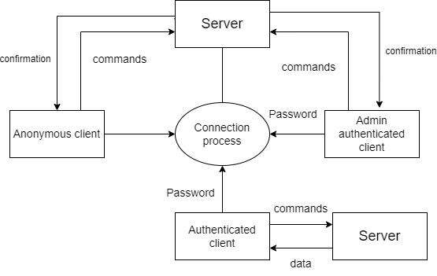

## 

## Data Flow Diagram Level 1:

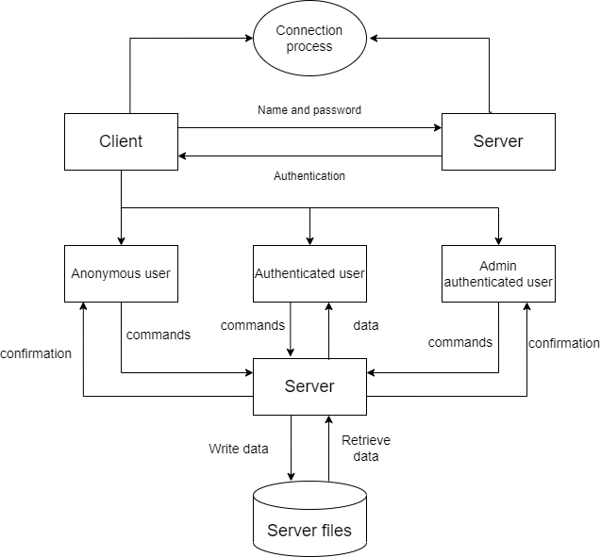

## 

## Flowchart for Remote phonebook:

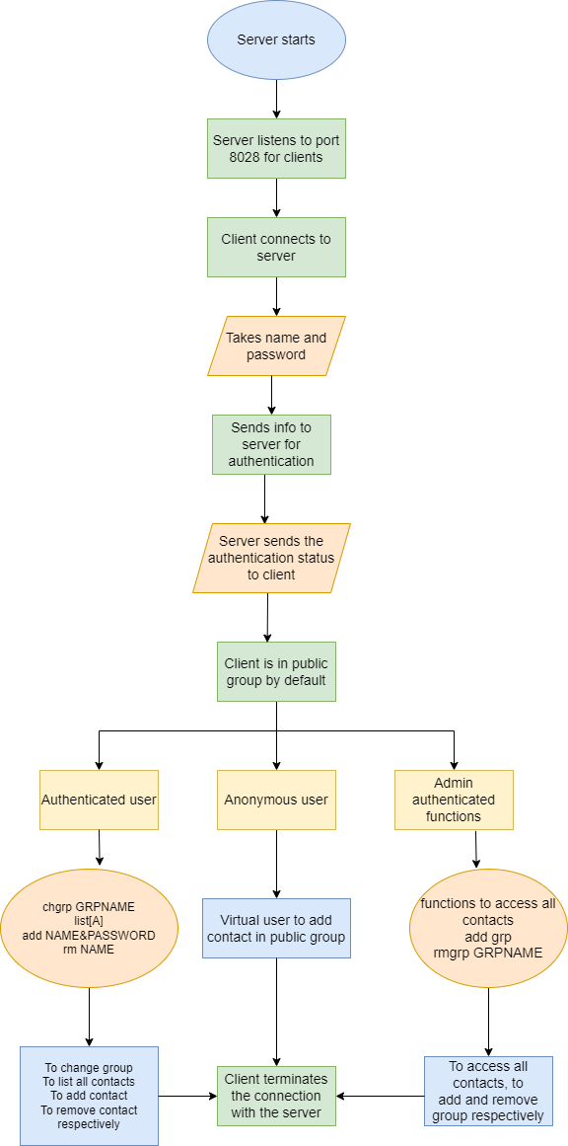

## Flowchart for user:

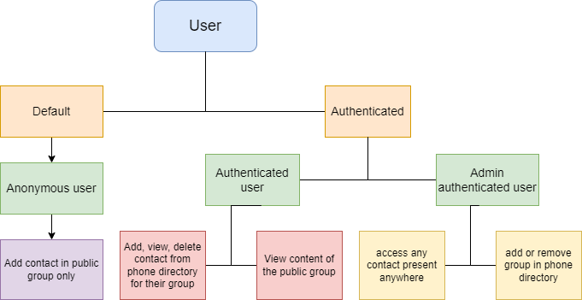

## Flowchart for functions of authenticated user:

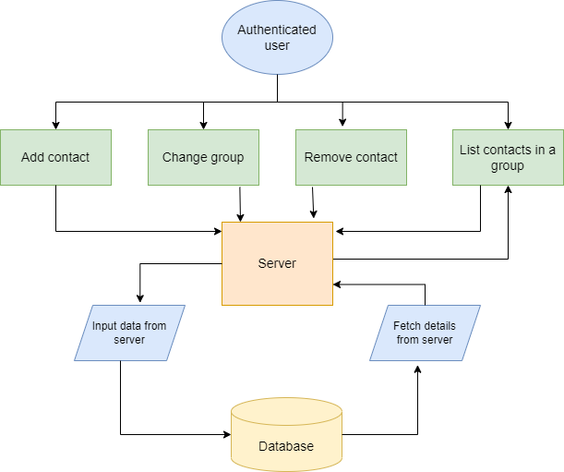

## Flowchart for functions for admin authenticated user:

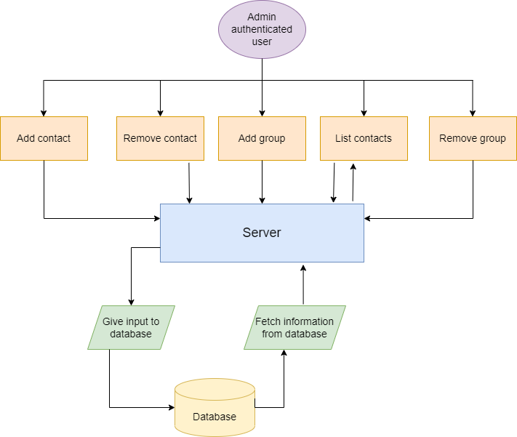

1. **Environment Description: -**
   1. **Time Zone Support: -** IST- Kolkata
   2. **Language Support: -** English
   3. **User Desktop Requirements: -**

* 64-bit processor, 1 GHz or faster
* At least 10 GB free hard drive space
* At least 1 GB RAM **Server**
  1. **Server-Side Requirements:**
* 64-bit processor, 1 GHz or faster
* At least 2 GB free hard drive space
* At least 1GB RAM
  1. Deployment Considerations: -
  + Local storage is used
  + No network latency to consider
  + To scale buy a bigger CPU, more memory, larger hard drive, or additional hardware

**5.4.2**. Application Server Disk Space: -

No such disk space is required as the program is fully functional on online

IDE(s) as well. Local Operating System is required and some txt files to store the

records of phonebook.

**5.4.3**. Database Server Disk Space: -

No such disk space is required as the program is fully functional on online IDE(s) as

well. Local Operating System is required and some txt files to store the records of

phonebook.

**5.4.4**. Integration Requirements: -

* Language: - C
* Tools: - Valgrind, Makefile ,Cunit, gprof, splint, gcov
* Complier: - gcc
* Linux Environment

**5.4.5**. Network: - End to End

**5.5 Configuration: -**

**5.5.1**. Operating System: - Linux environment

1. **Reference: -**

The references are:

* <https://www.geeksforgeeks.org/socket-programming-cc/>
* <https://www.javatpoint.com/file-handling-in->c
* <https://www.educative.io/answers/how-to-create-a-simple-thread-in-c>

1. TOOLS AND TESTING

## Gcov report:

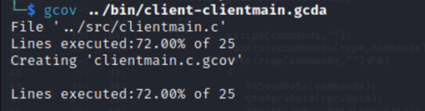

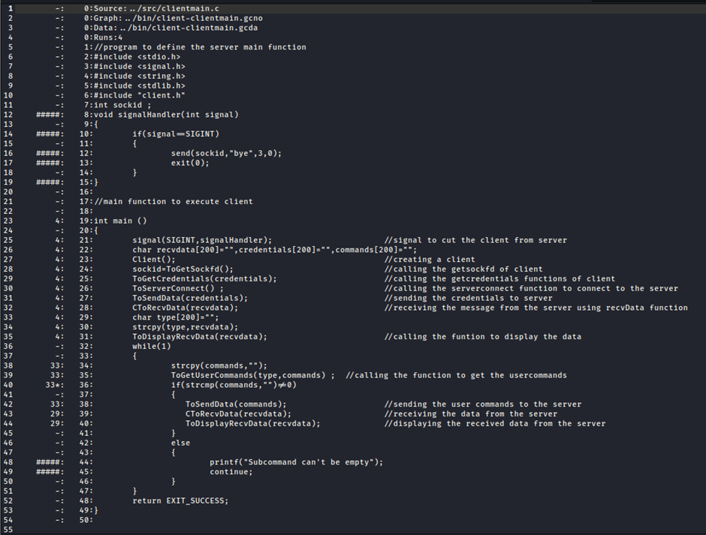

## Gprof report:

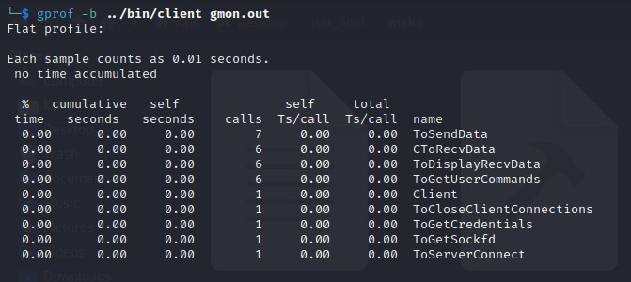

## Splint report:

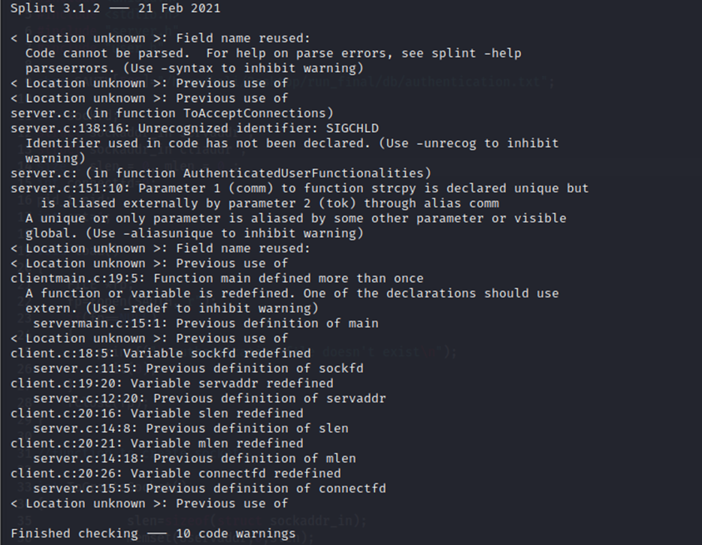

## Valgrind report:

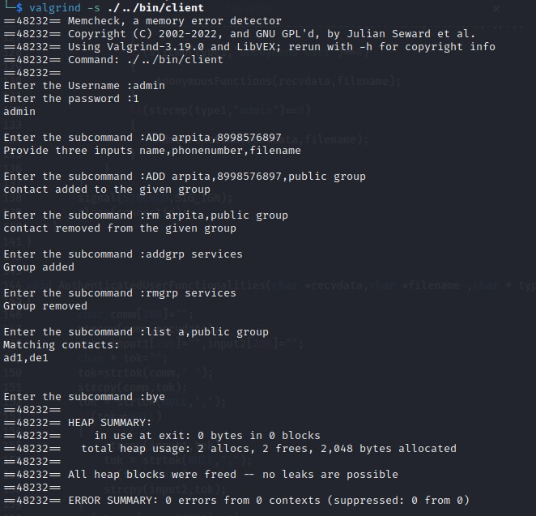

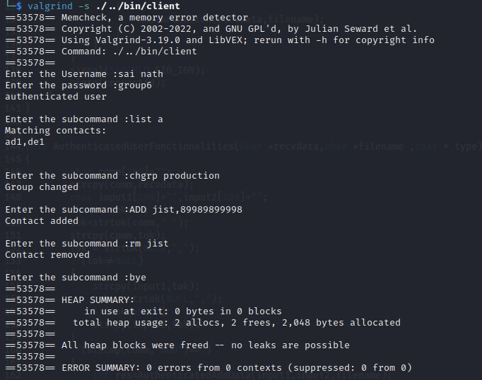

# TESTING REPORT

## Unit testing report:

## Integration testing report:

Case 1:Anonymous user

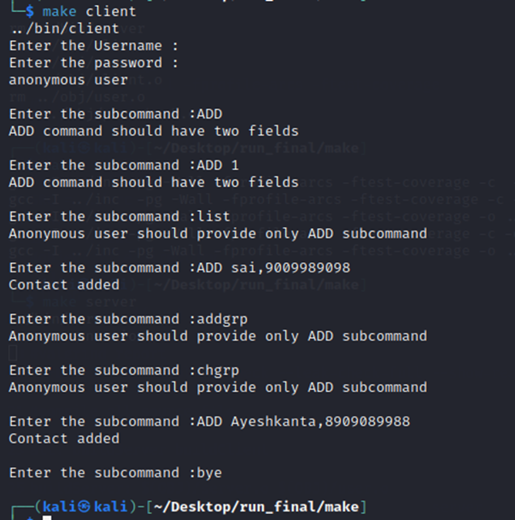

Case 2:Authenticated user

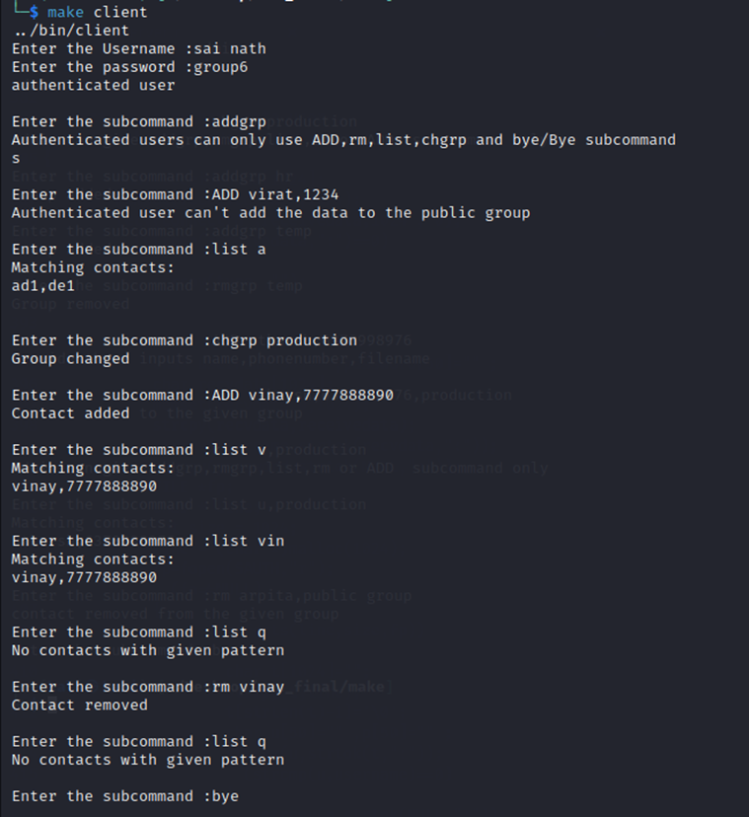

Case 3:Admin authenticated user

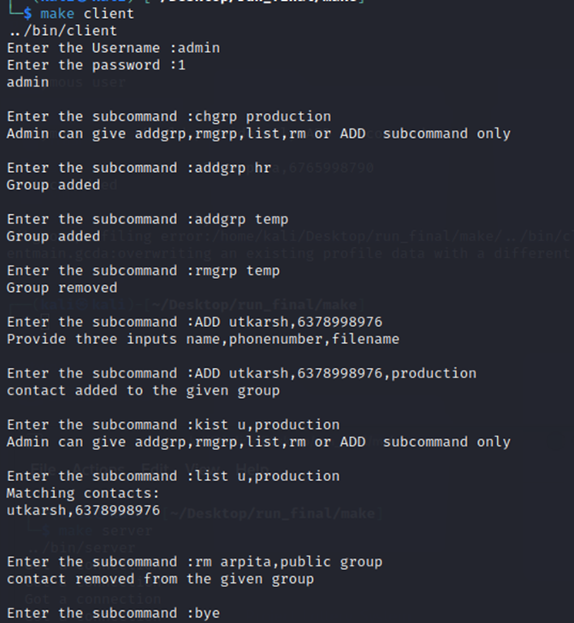

Case 4: Handling multiple clients

